JMeter 2.6 发布了，该版本要求 Java 5 的环境。2.6 版本包含众多改进：

主窗口中的新的工具栏



新增一个启动图标用于启动测试而忽视暂停计时器

http://www.spasvo.com/ckfinder/userfiles/images/20130329_15.png

外观主题增加 CrossPlatform

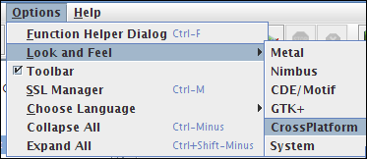

上下文菜单增加复制节点的项

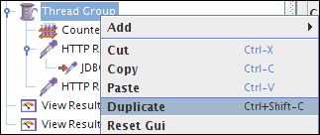

JMeter tree view - search facility

Functionality to search by keyword in Samplers Tree View

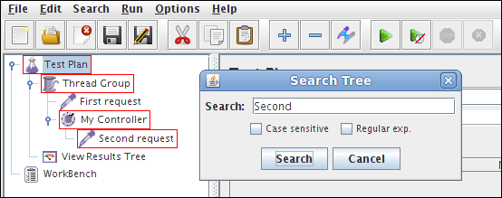

HTTP Request - raw request pane

Improve HTTP Request GUI to better show parameters without name (GWT RPC request or SOAP request for example)

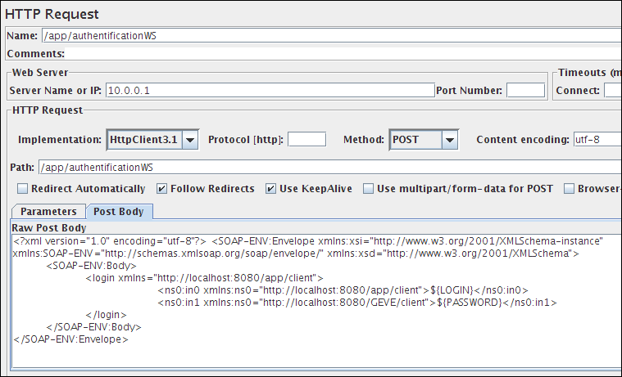

HTTP Request - other changes

     Allow multiple selection in arguments panel  
    Allow to add (paste) entries from the clipboard to an arguments list  
    Ability to move variables up or down in HTTP Request

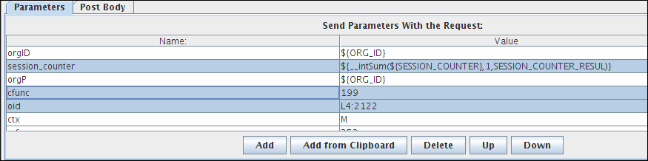

HTTP Request - file protocol

Better support for file: protocol in HTTP sampler

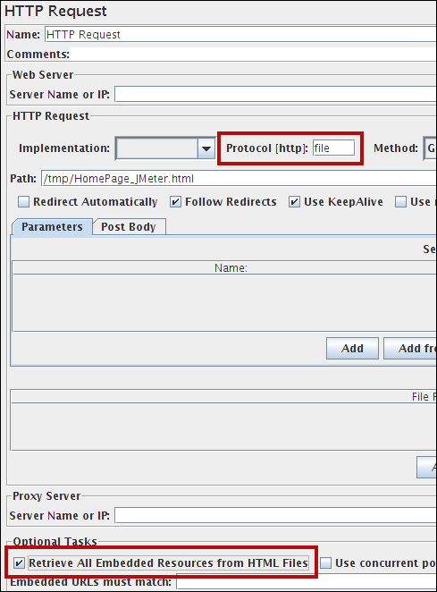

Retrieve embedded resources with file: protocol

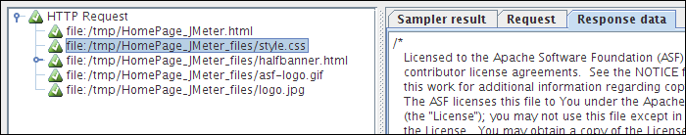

HTTP Request - Ignore embedded resources failed

Enable "ignore failed" for embedded resources

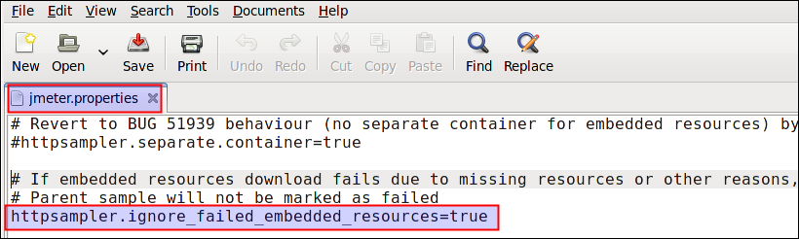

Parent success with a embedded resource failed

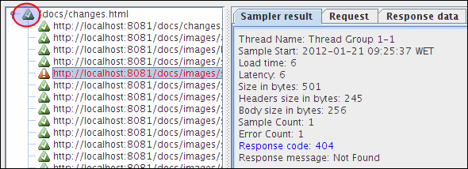

View Results in Table - child sample display

Add option to TableVisualiser to display child samples instead of parent

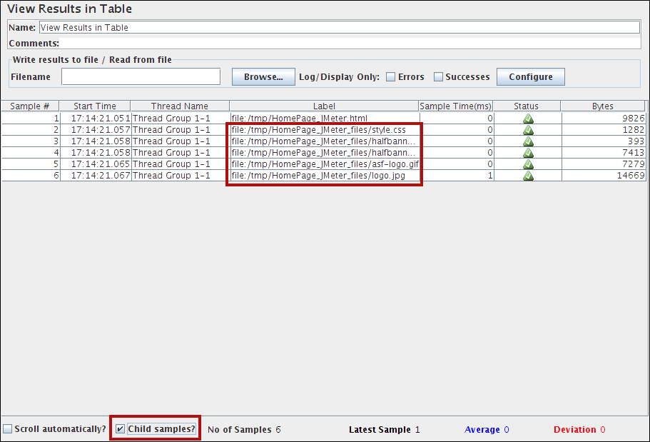

Key Store - multiple certificates

Allowing multiple certificates (JKS)

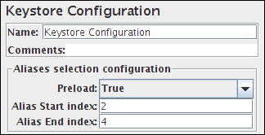

Aggregate graph improvements

Some improvements on Aggregate Graph Listener:

    new GUI for settings  
    dynamic graph size  
    allow to change fonts for title graph and legend  
    allow to change bar color (background and text values)  
    allow to draw or not bars outlines  
    allow to select only some samplers by a regexp filter  
    allow to define Y axis maximum scale

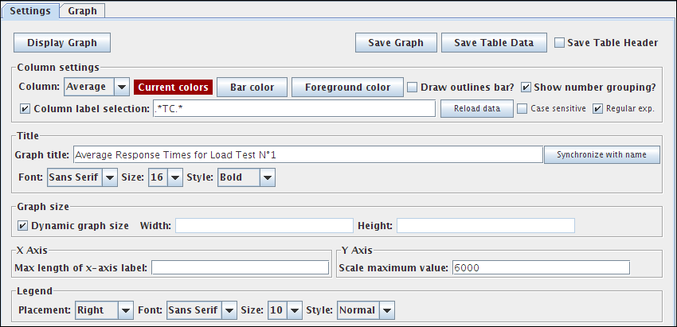

Aggregate Graph bar

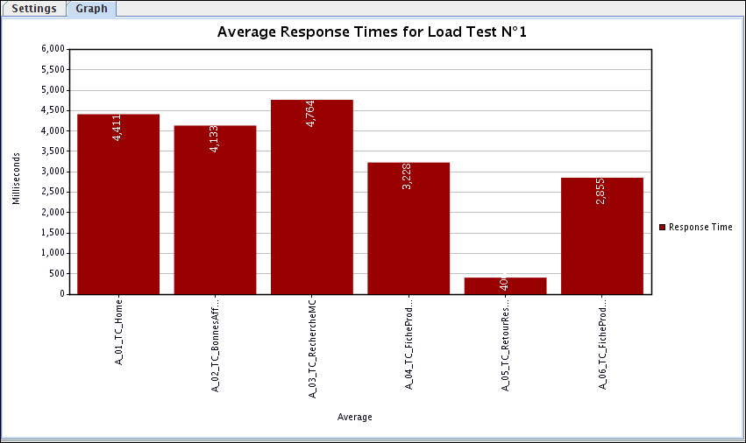

Counter - new reset option

Add an option to reset counter on each Thread Group iteration

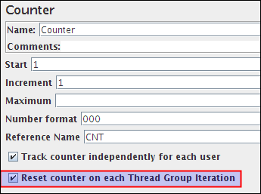

Functions

     Add a new function __RandomString to generate random Strings  
    Add a new function __TestPlanName returning the name of the current "Test Plan"  
    Add a new function __machineIP returning IP address  
    Add a new function __jexl2 to support Jexl2

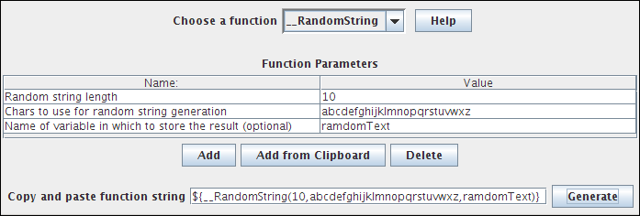

User Defined Variable improvements

     Add a comment field in User Defined Variables  
    Allow to add (paste) entries from the clipboard to an arguments list  
    Ability to move up or down variables in User Defined Variables

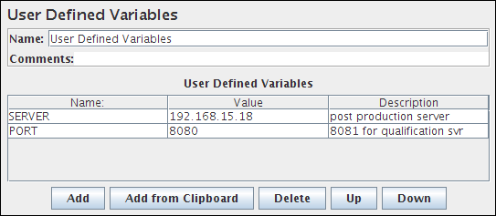

View Results Tree

In View Results Tree rather than showing just a message if the results are to big， show as much of the result as are configured

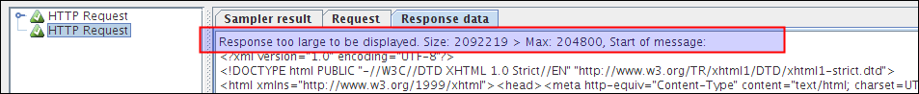

Controllers - change elements

Add ability to Change Controller elements

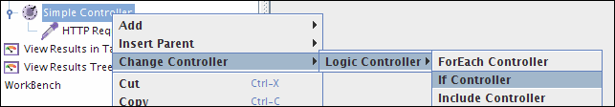

JDBC pre- and post-processor

Add JDBC pre- and post-processor

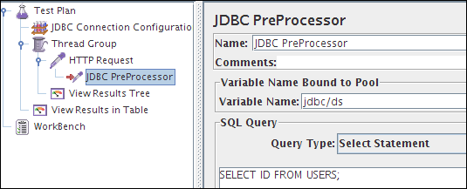

JDBC transaction isolation option

Allow to set the transaction isolation in the JDBC Connection Configuration

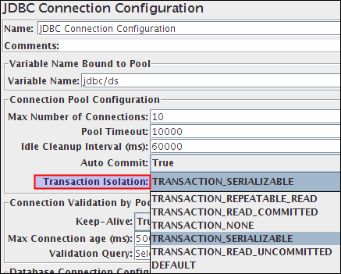

Poisson Timer

Add a Poisson based timer

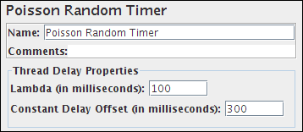

GUI and OS interaction

Support for file Drag and Drop.

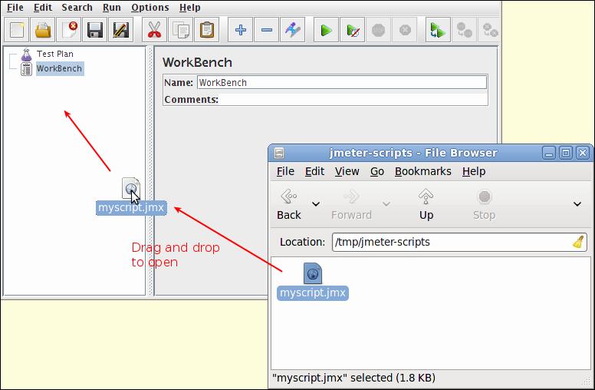

Confirm Remove Dialog box

Add a dialog box to confirm removing the element(s) when Remove action is called

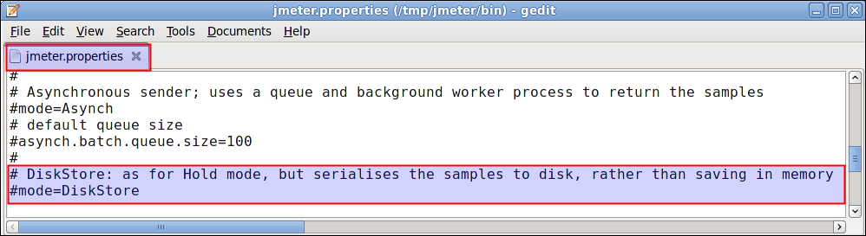

The dialogue can be skipped by setting the JMeter property confirm.delete.skip=true  
Remote batching support

Use external store to hold samples during distributed testing， Added DiskStore remote sample sender: like Hold， but saves samples to disk until end of test

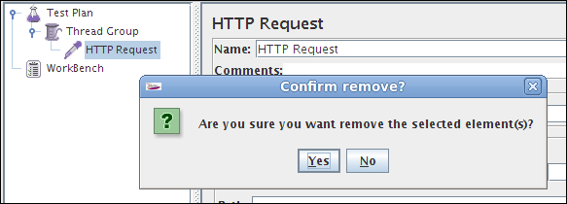

JMS Subscriber sampler

With JMS Subscriber， ability to use Selectors

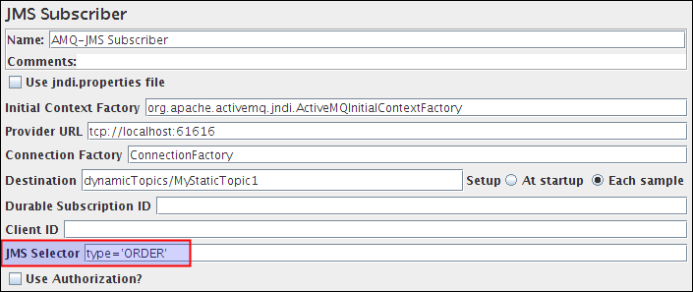

New Logger Panel

A new Log Viewer has been added to the GUI and can be enabled from menu Options > Log Viewer:

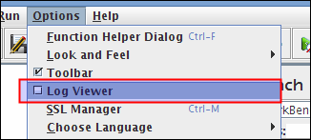

This Log Viewer shows the jmeter.log file， and useful (for example) to debug BeanShell/BSF scripts:

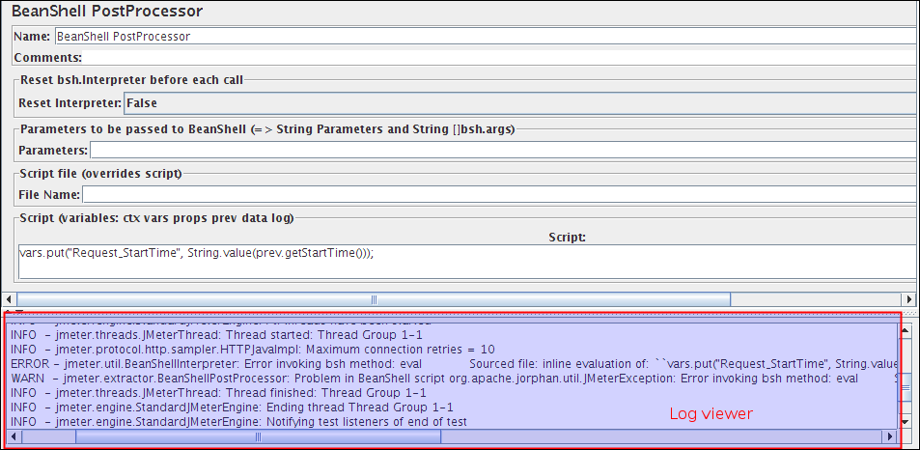

The menu item Options / Choose Language is now fully functional

The menu item Options / Choose Language now changes all the displayed text to the new language provided all messages are translated. You can help on this by translating into your language.  
Legacy JMX and JTL Avalon format support restored

Support for reading/writing the original Avalon XML format of JMX (script) and JTL (sample result) files was dropped in JMeter version 2.4. JMeter can now read the Avalon format files again， however there is no support for saving files in the old format.  
JMeter jars available from Maven repository

JMeter jars are now available from Maven repository.

完整的内容请看：http://jmeter.apache.org/changes.html